Setting up the ORS Backend:
- Author - Kiernan King
For the backend, they recommend using OpenStreetMap to gather a location dataset, it is exported as a .osm file so we will need to convert to .csv file.

To use OpenStreetMap, we want to use their API (v0.6) to import data via JSON file to the database. They recommend doing it via Docker, with the install process here. It requires an OSM extract and a working docker installation.

My system required WSL 2 (Windows subsystem of Linux) instead of Hyper-V, but as there was no prompt in the Docker installer itself, it must be done manually following the instructions here for updating the correct Linux kernel package.

After successfully installing Docker and the OSM image from Geofabrik, we are going to install and run ORS with Dockerhub’s hosted Openrouteservice image here.
- First, we need to double-check if the machine has CPU virtualization enabled
  - Do so by navigating to Task Manager > Performance > CPU
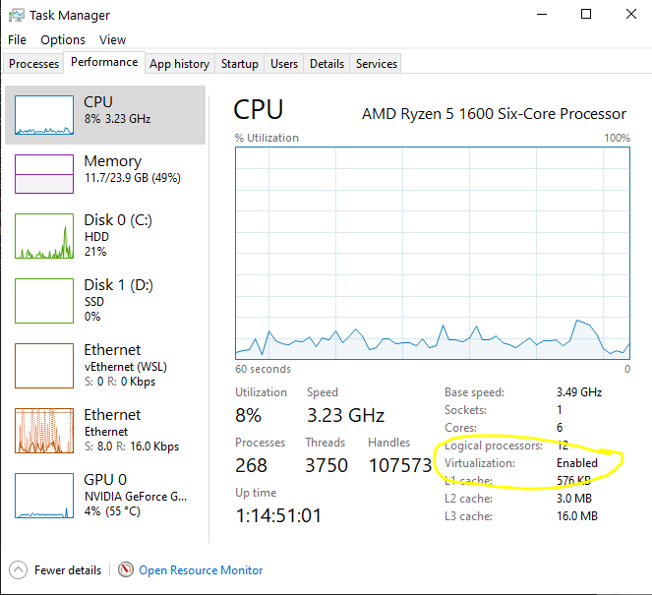

- Then, launch Docker Desktop and verify in Task Manager that there is a process called ‘Vmmem’ that is using a decent amount of memory.
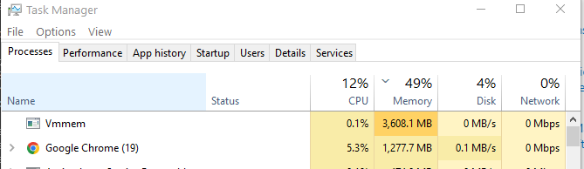
- We need to create a folder to store our OSM files in C:/OSMFiles, as well as an ors-config folder in C:/ors-config to store our ors-conf.json file.
    - Place the Geofabrik north-america-latest.osm.pbf inside this folder.
- We first have to verify that our root directory is correct by running the command ‘docker info’
  - The information below should show up (I blocked out some personal information), but we need to focus on the Docker Root Dir, which should be /var/lib/docker :
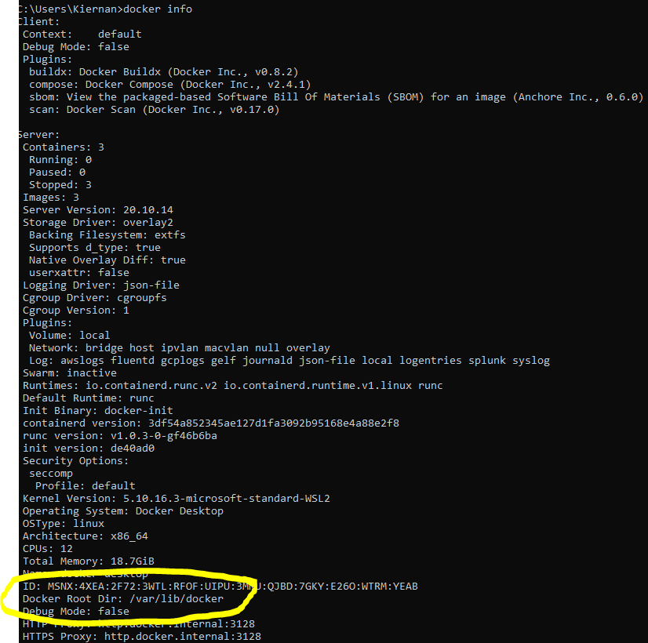

- We start this by opening up our command terminal and running the command ‘docker pull openrouteservice/openrouteservice’. This will download all components necessary from ORS.
- Next, we set up the map (our .osm.pbf file) for use with ORS via port 8080 by running this command in an administrator command prompt:
  - docker run -dt --name ors-app -p 8080:8080 -e BUILD_GRAPHS=True -v /var/lib/docker/graphs:/ors-core/data/graphs -v /var/lib/docker/elevation_cache:/ors-core/data/elevation_cache -v C:/ors-config:/ors-conf -v C:/OSMFiles/north-america-latest.osm.pbf:/ors-core/data/osm_file.pbf -e "JAVA_OPTS=-Djava.awt.headless=true -server -XX:TargetSurvivorRatio=75 -XX:SurvivorRatio=64 -XX:MaxTenuringThreshold=3 -XX:+UseG1GC -XX:ParallelGCThreads=4 -Xms1g -Xmx2g" -e "CATALINA_OPTS=-Dcom.sun.management.jmxremote -Dcom.sun.management.jmxremote.port=9001 -Dcom.sun.management.jmxremote.rmi.port=9001 -Dcom.sun.management.jmxremote.authenticate=false -Dcom.sun.management.jmxremote.ssl=false -Djava.rmi.server.hostname=localhost" openrouteservice/openrouteservice:latest
- If successful, you should see a long hexadecimal string (as seen below), which means Docker has started setting up your ORS container.
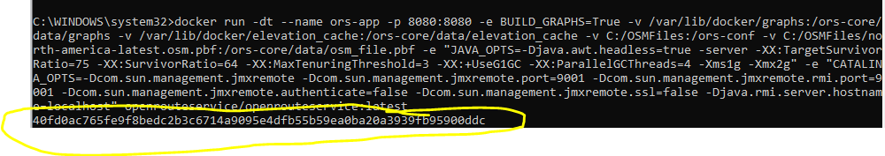
- Next, as you should already have Docker Desktop launched, navigate to the ‘Containers/Apps’ tab (should be there by default) and select the ‘ors-app’ that should have the status ‘RUNNING’ on port 8080.
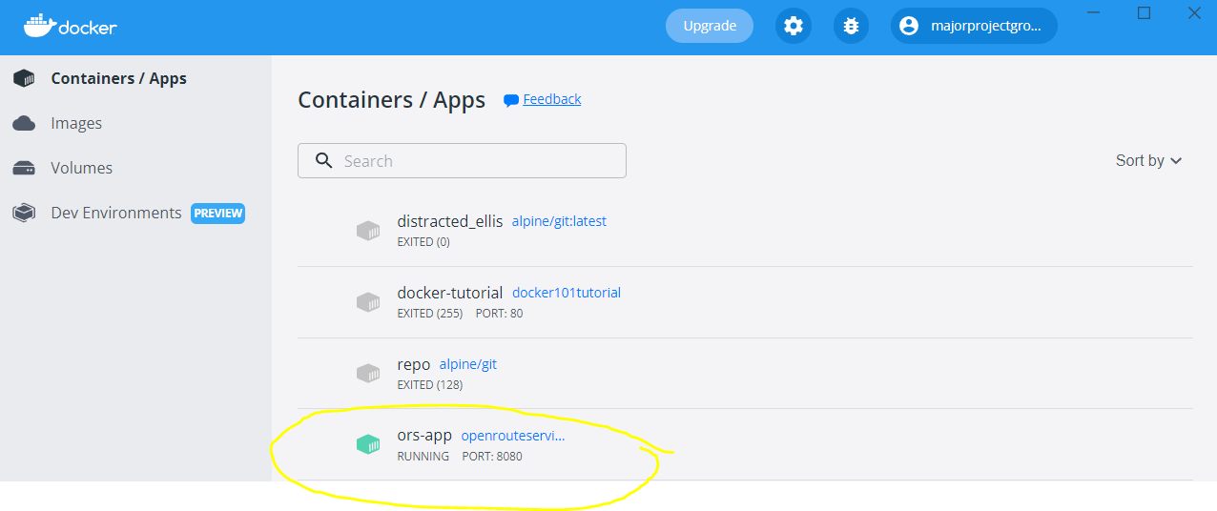
- After you select the ‘ors-app’, you should be in the ‘Logs’ tab.
- Should have some error messages in the log, but it will still deploy and tell you it setup successfully.
  - Ran into some issues on the outside with my machine and running this on there, not too sure how much more progress will be made as I can only do so much by myself.

